|  |  |
| --- | --- |
| EGC_Black | Student Name \_\_\_\_\_\_\_\_\_\_\_\_\_\_\_\_\_\_\_\_\_\_\_  **Eastern Goldfields College**  Mathematics Methods 2017  Test 311– Calculator Free Section |
| Working Time: 20 minutes | Total Marks: 16 marks |

**Question 1 [3 marks]**

Evaluate

$$\left(sin\frac{π}{6}\right)\left(cos210°\right)+(tan\frac{3π}{4})$$

**Question 2 [2 marks – 1, 1]**

1. Find the maximum value of the function y = 7 – 2 cos (.
2. Find the period of the function y = -4 tan(2πx)

**Question 3 [8 marks – 1, 1, 2, 2, 2]**

Given the functions f(x) = 17 – 3x h(x) = 

g(x) = x2 – 3x + 11 j(x) = 4 − 

determine

(a) h(0)

(b) g(−2)

(c) f(2t – 1)

(c) x such that f(x) = g(x)

(d) the domain and range of h(x)

**Question 4 [3 marks]**

The grid below shows a graph of y = cos(x) from 0 to 3π.

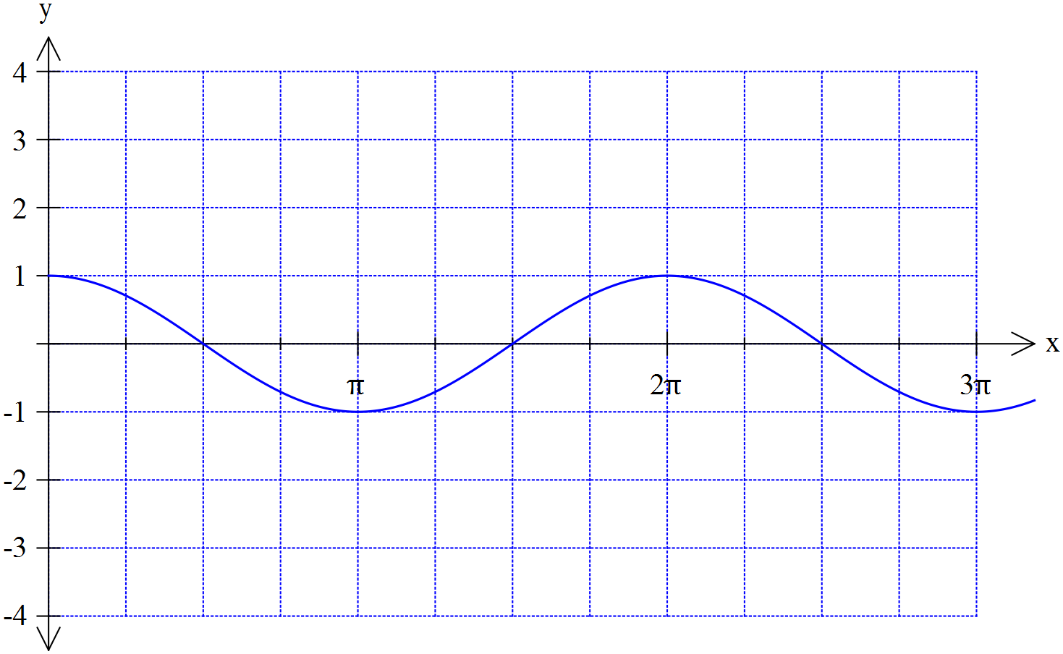

Plot the graph of y = -3 cos (2x) on the axes above

|  |  |
| --- | --- |
| EGC_Black | Student Name \_\_\_\_\_\_\_\_\_\_\_\_\_\_\_\_\_\_\_\_\_\_\_  **Eastern Goldfields College**  Mathematics Methods 2017  Test 311– Calculator Assumed Section |
| Working Time: 35 minutes | Total Marks: 30 marks |

**Question 5 [5 marks]**

Indicate which of the following represent functions with the letter **F**. **For those that are functions, state the natural domain and corresponding range.**

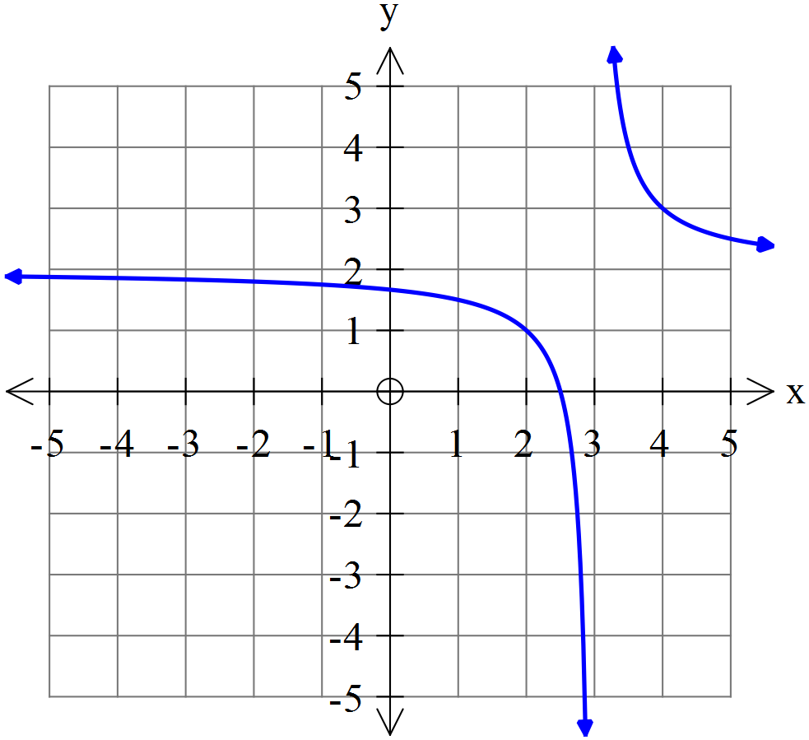 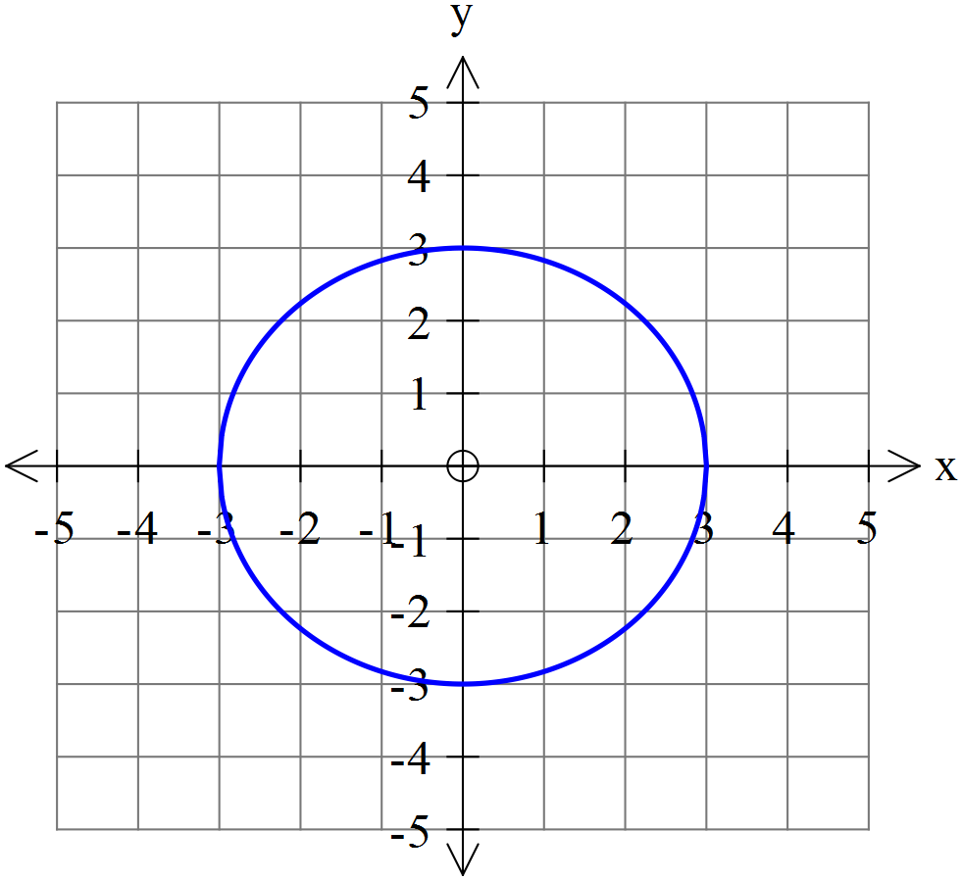 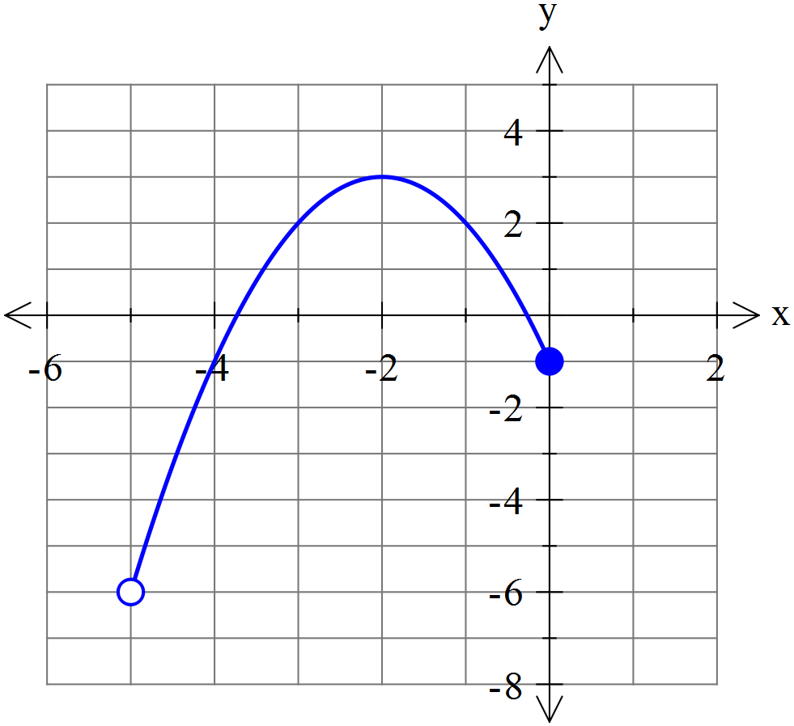

**Question 6 [8 marks – 2, 2, 2, 2]**

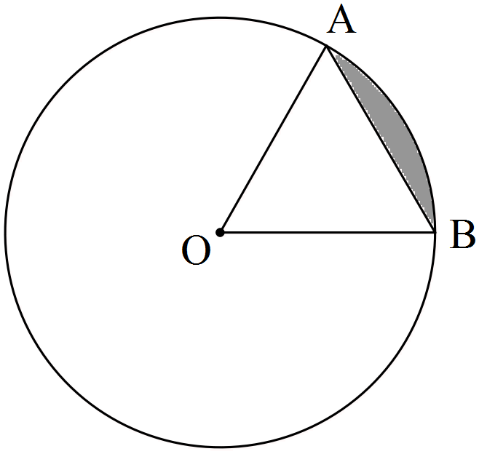

The circle shown with centre O has a radius of 3π cm.

If the size of ∠AOB = 60°, determine the

(a) area of triangle AOB as an **exact** value in terms of π.

(b) length of the ***major*** arc AB accurate to 2 decimal places.

(c) area of the ***minor*** sector AOB to the nearest cm2.

(d) area of the ***minor*** segment (shaded) formed by the chord AB round to two decimal places.

**Question 7 [5 marks]**

Triangle ABC drawn below has sides of 32 cm, 46 cm and 48 cm. The circle with a radius of 11 cm is inscribed inside the circle and just touches the three sides of the triangle. Lengths of the lines from A to circle are equal.

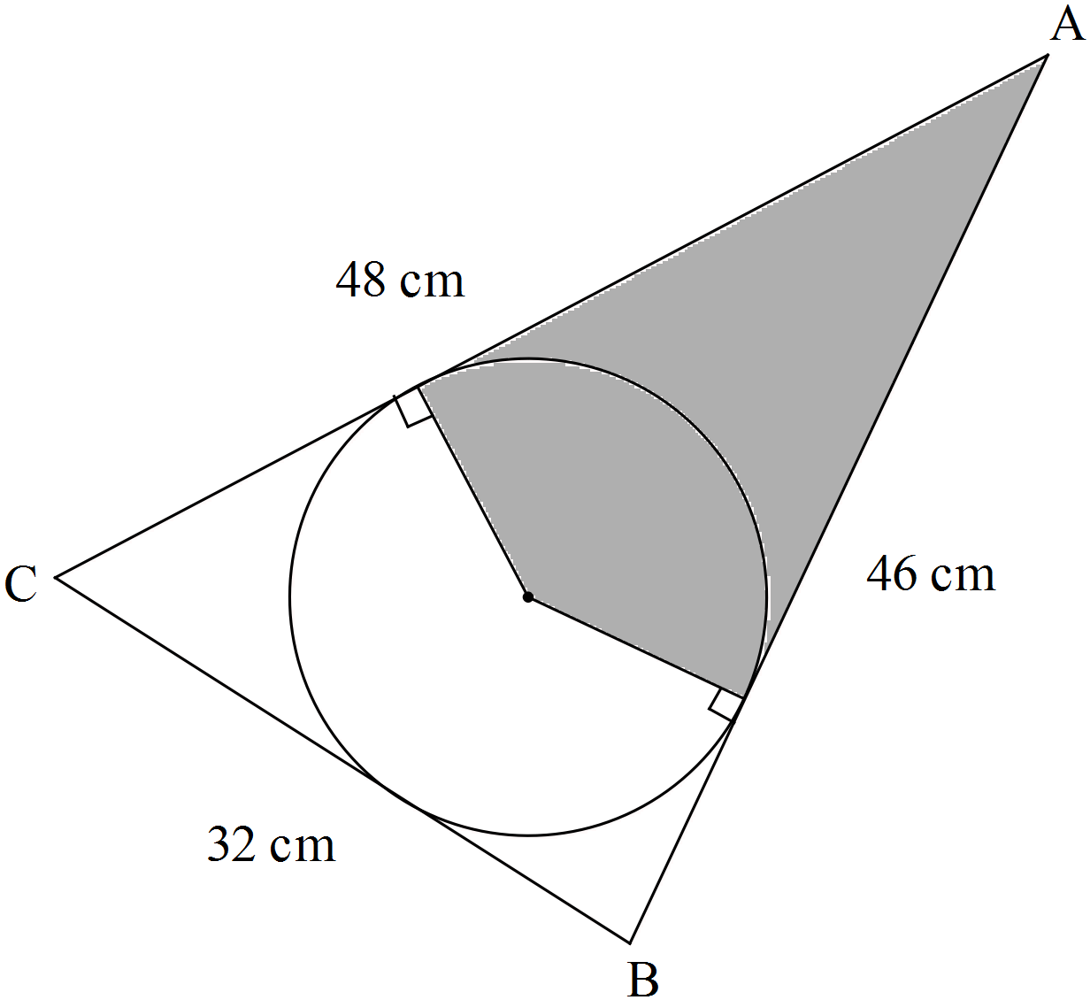

Note: Diagram not drawn to scale.

Determine the area of the shaded region. (Hint: First find the size of ∠BAC).

**Question 8 [5 marks –1, 1, 1, 2]**

|  |  |
| --- | --- |
| Shown to the right is a graph of the function f(x)  Using your knowledge of transformations sketch the following. |  |

1. y = f(x + 4) b) y = f()

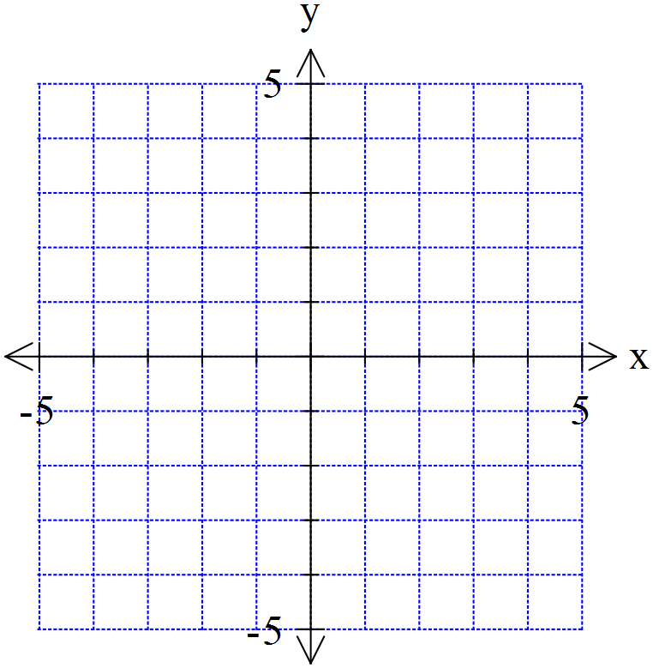



1. y = f(-x) d) y = -2f(x)

 

**Question 9 [7 marks – 2, 3, 2]**

a) State the rule for a circle with a radius of with a centre of (-2,1).

b) Write the rule in the form x2 + y2 + dx + ey = f

1. Determine the distance from the closest point on the circle to the origin at (0,0)

